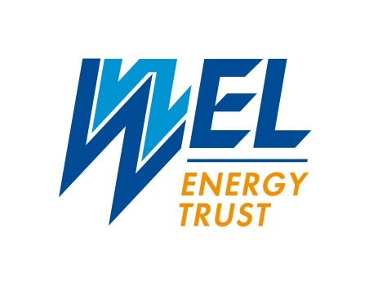Community Support Round

**Closed 31 March 2025**

**Successful Applicants**

| Organisation Name | Funds Approved |
| --- | --- |
| Art in Nature Arboretum Trust | $25,000 |
| Bridge Housing Charitable Trust | $40,000 |
| Community Link Trust | $47,500 |
| Dress for Success Hamilton Trust | $23,000 |
| EquiPotential NZ Inc | $22,500 |
| Graeme Dingle Foundation Waikato | $55,000 |
| Maungatautari Ecological Island Trust | $65,000 |
| Orchestras Central Trust | $55,000 |
| Phoenix House Charitable Trust | $50,000 |
| Pivot Bail Charitable Trust | $40,000 |
| Prison Care Ministries | $30,000 |
| Pukete Neighbourhood Association Inc | $38,000 |
| Smart Waikato Trust | $45,000 |
| Swim Waikato Inc | $75,000 |
| Taniwharau Rugby League Sports and Cultural Club Inc | $140,000 |
| Te Awa River Ride Charitable Trust | $22,500 |
| The Hamilton Methodist Social Services Trust | $25,000 |
| The One Victoria Trust Board Inc | $60,000 |
| Waikato Environment Centre | $95,000 |
| Waikato Equitherapy Inc | $18,000 |
| Waikato Screen NZ Ltd | $50,000 |
| Waikato Women’s Refuge – Te Whakaruruhau | $75,000 |
| Waru Rua Rima Charitable Trust | $12,500 |
| Western Community Association Inc | $75,000 |